|  |
| --- |
| Home | AIUB PROJECT REPORT **SIGN LANGUAGE TRANSLATOR**  **COURSE:**  HUMAN COMPUTER INTERACTION |

**INSTRUCTOR:**

PROF. DR. TABIN HASAN

**GROUP MEMBERS:**

|  |  |  |
| --- | --- | --- |
| **NAME** | **ID** | **SEC** |
| MD. TAKIB UDDIN SARKER | 20-42679-1 | A |
| FAHIM ANWAR | 20-42305-1 | A |
| SAKIF AL FARUQUE | 20-42308-1 | B |
| ASIF SHARIF AKASH | 20-42647-1 | B |

Department of Computer Science

Faculty of Science & Technology

American International University Bangladesh

**Spring , 2023**

* **Introduction**

Around 90 million deaf people utilize more than 300 distinct sign languages together throughout the world. Deaf people and their community engage in a distinctive form of personal communication known as sign language. Hand gestures, signs, facial expressions, and visual gestures all communicate meanings and information. These physical gestures can be used singly or in combination to convey letters, numbers, words, and sentences. The use of sign language is not just for one-on-one communication; it can also be used in sophisticated interactive environments. For instance, in smart home applications, a hand gesture can be used in place of a verbal phrase to refer to a feature or an option. Technically speaking, the hand movements employed in sign languages can be divided into two categories: static hand gestures and dynamic hand motions. The significance of researching sign language linguistics and categorizing their gestures resides in how deaf people use the language elements and how they can be understood by those who receive sign language messages from other people.

Human-computer interaction (HCI), which has a wide range of uses, has become a necessary component of daily life. One of these applications is gesture recognition for sign language interpretation, in which pictures of hand movements from a sign language are input to a computer, processed, and turned into auditory or written output signals that users, including deaf individuals, may comprehend. Because of this, such HCI algorithms must be dependable, quick, flexible, and precise, especially when deaf persons are involved in emergencies. Therefore, there may be many methods and approaches for gesture input, gesture processing, and output interpretation depending on these criteria.

* **Project background**
* **Identification of problem:**

Hand gestures can be used in a variety of situations to interact with technology, including playing video games, piloting unmanned aerial vehicles, operating medical equipment, etc. People with disabilities can also use these hand signals to communicate with the systems. The way we engage with the system may be constrained by traditional interface methods like the keyboard, mouse, touchscreen, etc. To communicate with any of these systems, physical contact is necessary. The same functionality can be interpreted by gestures without a physical interaction with the interfaced devices. Understanding these gestures might be difficult because they can seem differently on various people when executing the same action. The application of Deep Learning techniques might be able to solve this issue.

* **Background study**

Interpreters of sign language have a great deal of practice doing both simple and sophisticated hand motions rapidly and for extended periods of time. For a hearing-impaired audience, the work typically entails interpreting teachers' or conference speakers' words into American Sign Language (ASL). Designing a gesture language for computer input may benefit from the particular insight sign language interpreters have into whether hand movements are or are not related to hand and arm pain. While sign language interpreters employ intricate hand gestures to represent words, they are also well-versed in the straightforward hand gestures and motions that will likely be used in 3D gestures for HCI. Examples are the gestures for the letters and digits O, A, C, and V. These less complex movements are appealing for HCI because the hand postures are easily recognizable, distinct, and easier to distinguish via image capture.

* **Goals**

The goal is to identify the hand motions that are easy to produce and the ones that are related to hand pain when sign language interpreters made them repeatedly. The idea is that after frequently forming certain hand movements, sign language interpreters might relate them to various degrees of hand pain. If some motions are uncomfortable while others are not, the results can assist direct the design of 3D hand gestures for HCI tasks to lessen computer users' discomfort and weariness and increase productivity.

* **Methodology**
* **Methods & tools:**

OpenCV: Used for video processing, capturing frames, and displaying output.

MediaPipe: Utilized for hand detection and tracking.

Keras: Employed for loading the pre-trained model and making predictions.

LSTM (Long Short-Term Memory) and Dense layers: Integrated into the neural network model for gesture recognition.

* **Implementation planning**

1. Loading the pre-trained model: The project loads the trained model architecture from the "model.json" file and the matching weights from the "model.h5" file.
2. Video capture: The system records video frames from a selected video source or the camera.

c) Hand detection and tracking: Within the video frames, the signer's hand is detected and tracked using MediaPipe's hand monitoring module.

d) Gesture recognition: To anticipate the matching sign language gesture, the extracted hand landmarks are supplied into the loaded model.

e) Translation and visual representation: The recognized movements are converted into spoken or written language, and the result is shown on the screen.

* **Result**

The real-time efficiency and precision of the sign language detection system are demonstrated when identifying sign language motions. The pre-trained model's performance, which was developed using a dataset of sign language motions, determines how accurate the system is. Each prediction's outcome is printed to the console along with a description of the recognized motion.

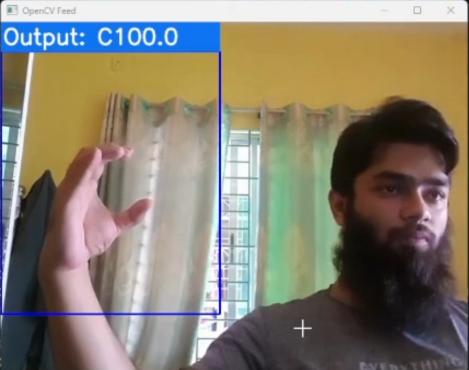

* **Discussion**
* **Findings**

In this project, machine learning-based software has been developed which is used for recognizing sign languages in English. With any particular gesture of the hand, it will identify the symbol that a human wants to show. For now, this project is only bound to recognize English alphabets.

* **Analysis**

This project is built with the concept of computer vision. Python open cv package is used to store the pictorial data. Again, it is assisting to match stored pictorial data and actual or real-time pictorial data. Tensorflow and Mideapipe are the heart of this project. Those packages are used for processing the data and providing the output with good accuracy.

* **Conclusion**
* **Recommendations**

Recently in this project, only a few alphabets are detected with good accuracy. In the future, the number of alphabets will be increased. Again, this software will be eligible to interpret the total sentence in English. Furthermore, other sign languages will be integrated for interpretation.

* **Conclusion**

This project was about detecting sign language with hand gestures and providing the interpretation of natural human languages with good accuracy. The python packages such as Tensorflow, Mideapipe, Numpy, Keras, Scipy, etc were used to develop this software. This software works in four stages,

1. Collect data
2. Develop a model
3. Train the model
4. Test the model

The data such as different types of body gestures were collected through Python open-cv package. A pre-developed model was chosen for development. After that, the model was trained with the collected data. Finally, the software was used to recognize some specific signs such as A, B, and C which is actually the model testing phase. In the future, this project will be expanded with more capabilities of interpretation.

* **Reference**
* Li, Y., Wu, H., Lin, X., & Lyu, Y. (2020). Sign Language Recognition Based on Deep Learning: A Survey. IEEE Transactions on Human-Machine Systems, 50(1), 67-78.
* Pu, J., Zhang, Y., & Yuan, J. (2019). Deep Learning for Sign Language Recognition and Translation: A Survey. IEEE Transactions on Human-Machine Systems, 49(2), 161-168.
* Athitsos, V., Sclaroff, S., & Betke, M. (2003). Detecting and Tracking Hands and Faces in Color Images. International Journal of Computer Vision, 63(1), 63-85.